**Train and run time complexities**

While training although we have stochastic gradient descent algorithm but there is also specialized algorithm for svm specially for dual form that algorithm is sequential minimal optimization (SMO) for optimization.

Along with sklearn there is also one library libsvm it is best library for training svm and it internally uses SMO for optimization.

Sklearn also internally uses libsvm in some cases.

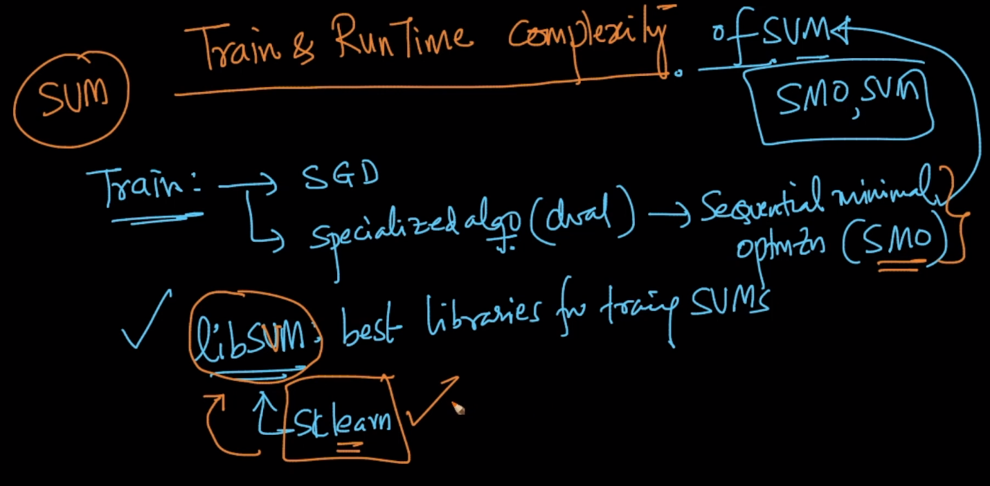

Training time complexity of svm is o(n2) for kernel svm

There are also some optimization algorithm which makes its complexity o(nd2)

So if n is large typically we do not use svm like in internet applications.

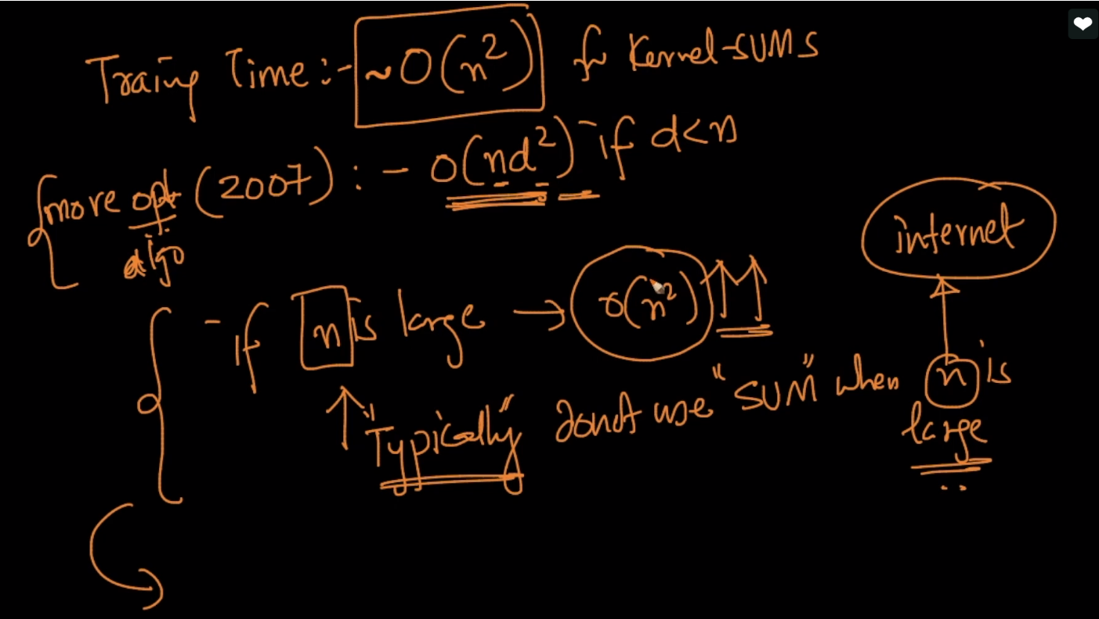

Runtime complexity is o(kd) where k is number of support vectors because for non-support vectors value of alpha is 0 therefore we don’t have to calculate it for non support vectors.

But the thing is we can’t control no. of support vectors like in RBF and soft-svm-formulation if can be from 1 to n.

But as run time complexity of logistic regression is o(n). therefore its complexity is better than svm

